Step 1: Open eBook and expand window
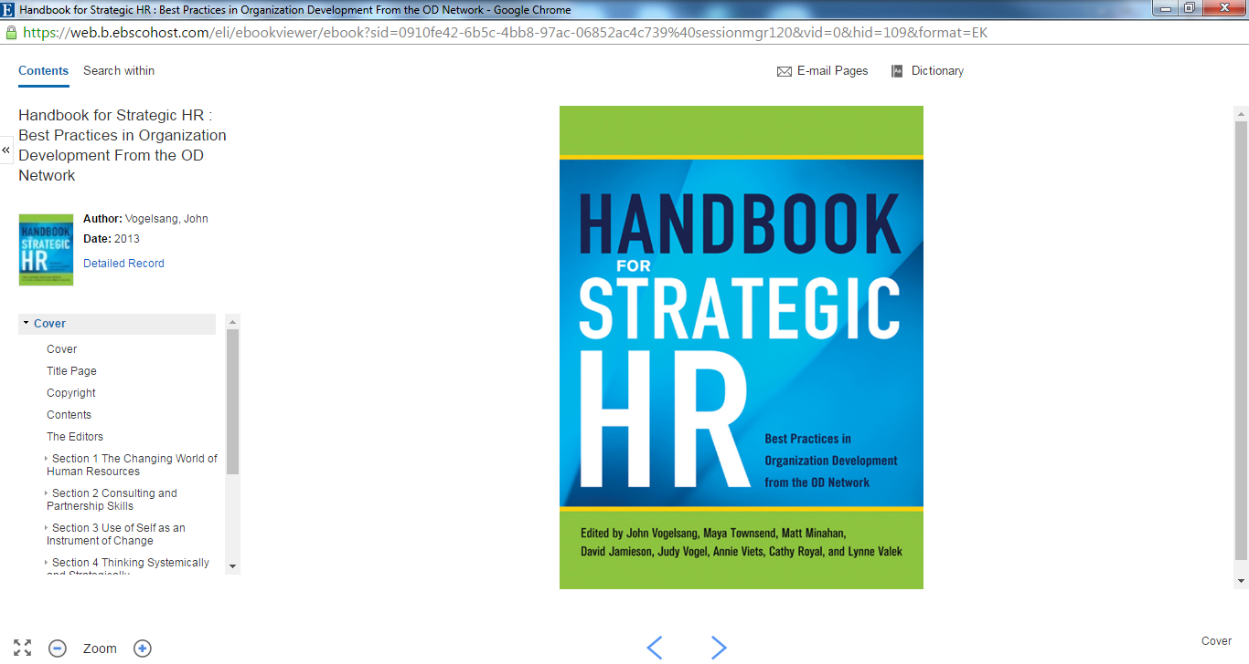
Step 2: Select E-mail pages (top of screen)
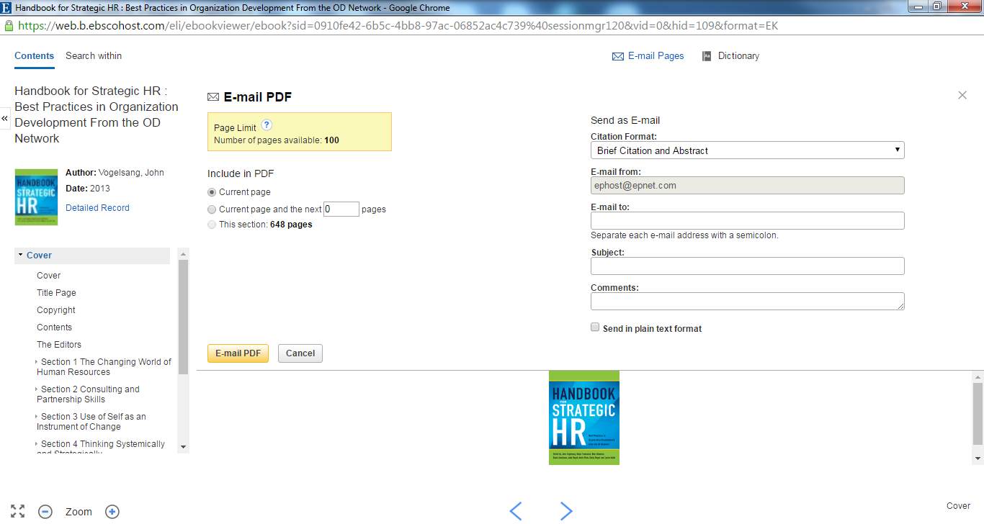

Step 3: Select a Section or Begin with Section One (located on the left of the screen)
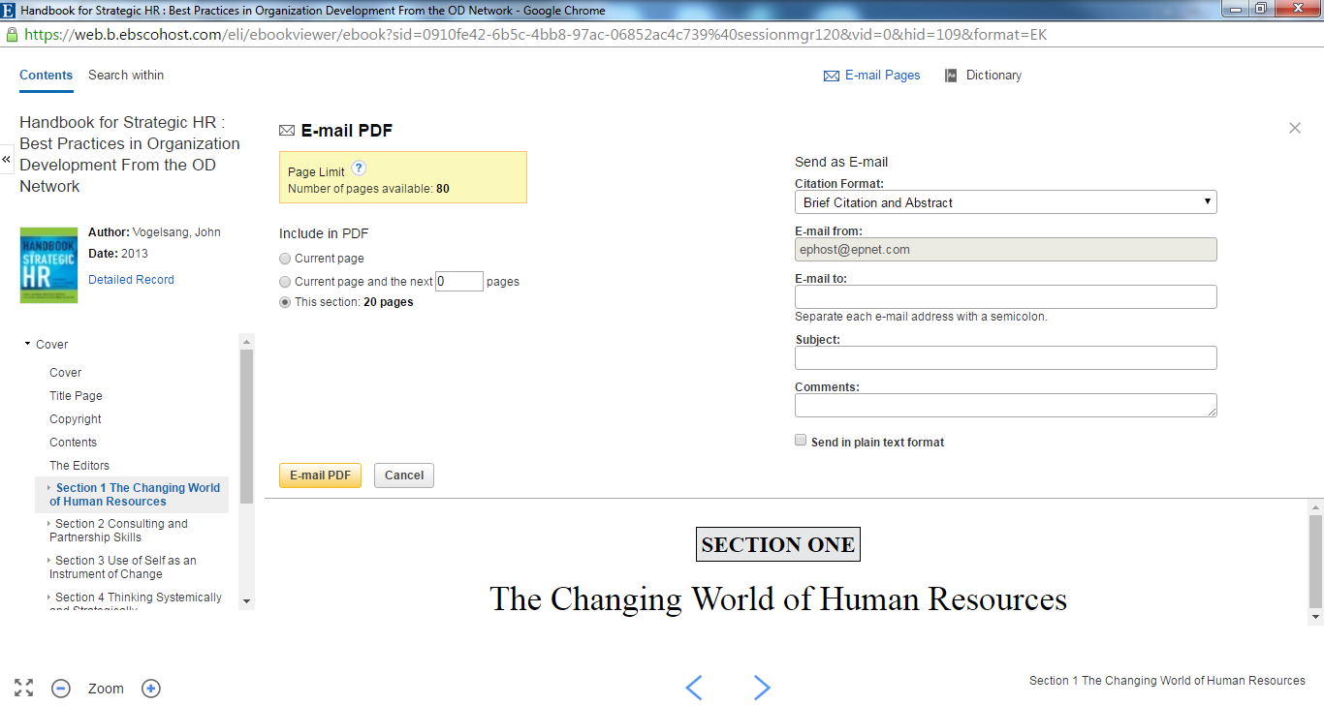
Step 4: Select “This Section” or place a number of pages between 1 and 99 (located under the E-mail PDF heading). Then Enter your email address on the right side of the screen. Once completed, press “E-mail PDF”.
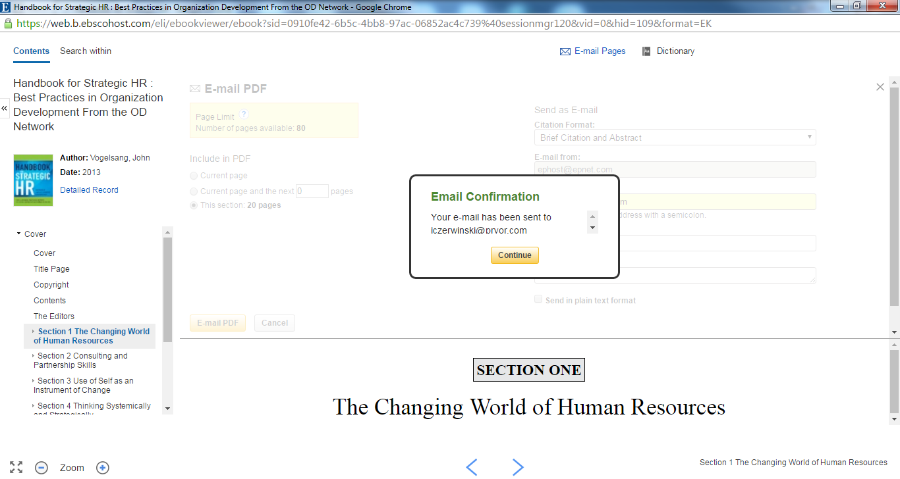

Step 5: Open email with PDF attachment from ephost@epnet.com. Once this attachment has been opened, you may save it to your desktop or print directly from this application.
